*Florida International University*

*School of Computing and Information Sciences*

Software Engineering Focus

Feature Document

User Story ID 731

**Name:** Delete Sub-Users

**Team Member(s):** Leandro Gonzalez,Luis Herrnsdorf

**Project:** Smart Stormwater (Smart City System) 2.0

**Product Owner(s)**: Emilio Lopez

**Mentor(s)**:

**Instructor**: Masoud Sadjadi

**User Story Name:** Delete Sub-Users

* Description: As an Admin, I want to be able to delete a sub-user’s account, so that I can revoke a user’s access to the system.

Acceptance Criteria

* The deleted user’s account will be removed from Firebase Authentication, making the credentials invalid.
* If the deleted user is an admin, all users under said admin are assigned as sub-users to the parent of the deleted user.
* All device assignment settings for the deleted user are deleted.

**Use Case**

* Name: Delete sub-user
* Actor: Admin
* Preconditions: Admin is logged in, admin has sub-users
* Description: On the ‘Users’ page, the admin selects a user by clicking on it. Admin clicks on the ‘Delete’ button of the selected user, a floating window comes up asking the admin to confirm that he/she wishes to delete the selected user account. If ‘Cancel’ is clicked, the window closes and the admin returns to the ‘Users’ page. If ‘Delete Profile’ is clicked, all the information for the selected user is deleted, and the account is closed; app redirects admin to ‘Users’ page, and the deleted user is no longer listed

**Use Case Diagram**

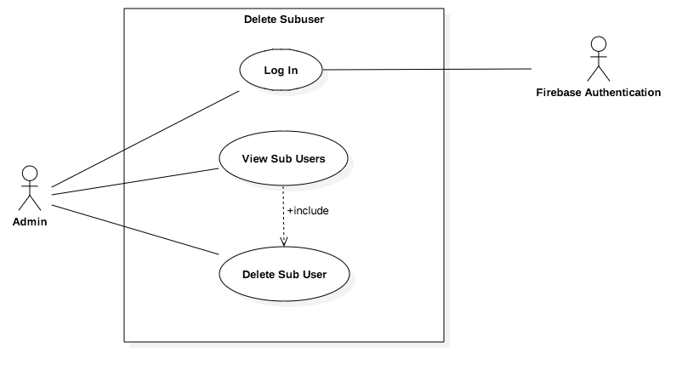

**Sequence Diagram**

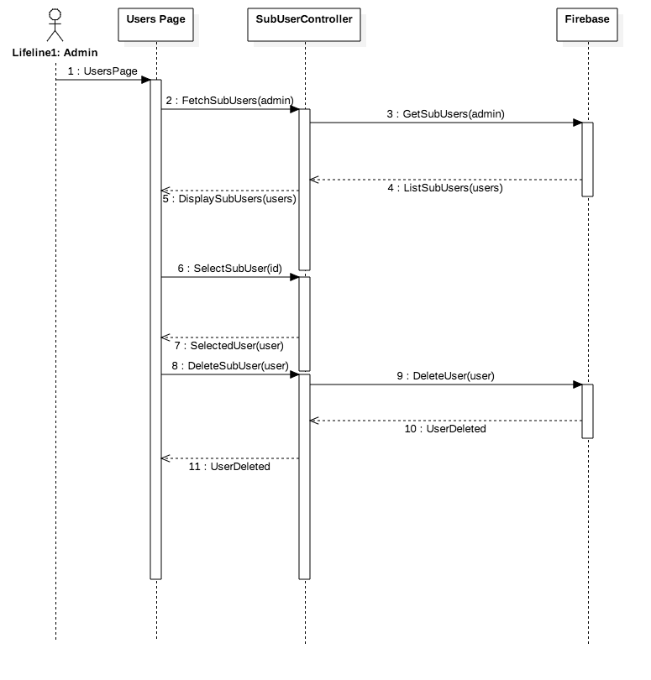

**Class Diagram**

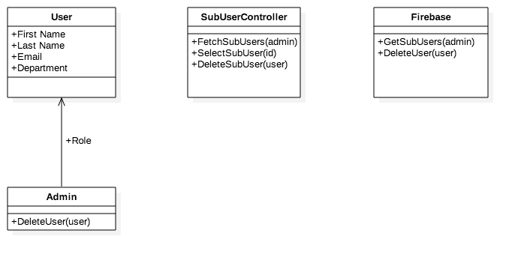

**Unit Test**

* Test case ID: DeleteSubUser001
* Description/Summary of Test: Admin deletes a sub-user’s account
* Pre-condition: Admin is logged in, admin has sub-users
* Expected Results: Sub-user’s account is deleted
* Actual Result: Sub-user’s account was deleted
* Status (Fail/Pass): Pass

**Visual User Guide**

